1. **Create a simulator based on 2\*2 matrix with 2 qubit and perform 3 operations. Here, if the matrix not exceeding 6\*6 than it is feasible one.**

The basics of the qubit matrix are:

1. A single qubit state is a 2×12×12×1 vector.
2. Two qubits → 4×14×14×1 state vector (tensor product).

A gate is represented by a unitary matrix:

* 1. 1-qubit gate → 2×22×22×2 matrix.
  2. 2-qubit gate → 4×44×44×4 matrix

The 3 operations to be performed are:

1. Hadamard (H) on first qubit
2. Pauli-X (NOT) on second qubit
3. CNOT (Controlled-NOT) on both qubits

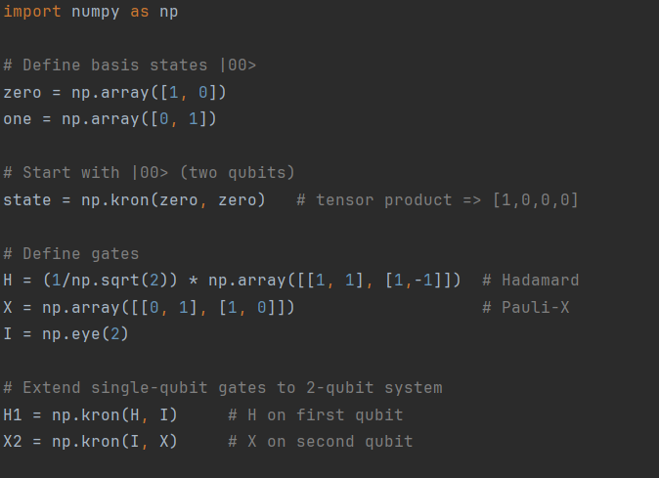

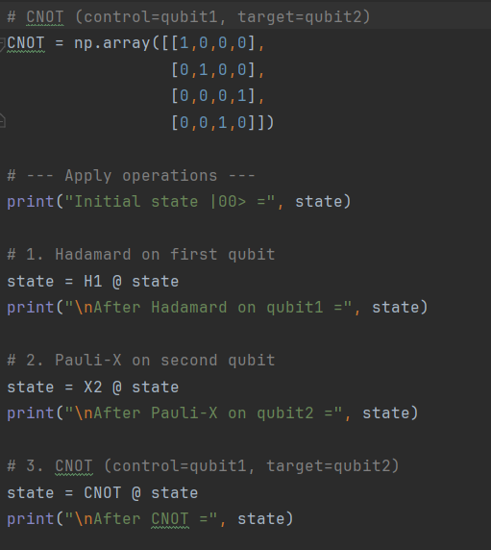

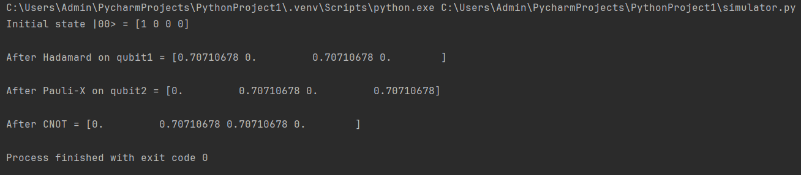

Therefore, the above matrix didn’t exceed the 6\*6 matrix, so the given matrix is feasible one.